An Ant Colony Optimization Algorithm for The 2D HP Folding Problem
Alena Shmygelska , Rosalia Aguirre-Hernandez and Holger H. HoosPradip
Ant Algorithms, Third International Workshop, ANTS 2002, pp 40-53, 2002
Abstract
The prediction of a protein’s structure from its amino-acid sequence is one of the most important problems in computational biology. In the current work, we focus on a widely studied abstraction of this problem, the 2-dimensional hydrophobic-polar (2D HP) protein folding problem. We present an improved version of our recently proposed Ant Colony Optimization (ACO) algorithm for This NP-hard combinatorial problem and demonstrate its ability to solve standard benchmark instances substantially better than the original algorithm; the performance of our new algorithm is comparable with state-of-the-art Evolutionary and Monte Carlo algorithms for this problem. The improvements over our previous ACO algorithm include long-range moves that allow us to perform modification of the protein at high densities, the use of improving ants, and selective local search. Overall, the results presented here establish our new ACO algorithm for 2D HP protein folding as a state-of-the-art method for this highly relevant problem from bioinformatics.
- The 2D HP Protein Folding Problem
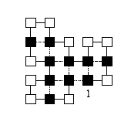
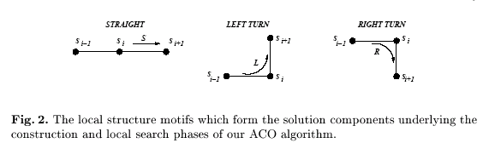
- Algorithm
( 1 ) Construction Phase
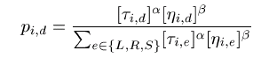
where τ_{i,d} is the pheromone value, η_{i,d} is the heuristic value and d∈{S,L,R} is a relative direction for all sequence position i.
( 2 ) Local Search
－ mocro-mutation neughbourhood
－ 1-exchange “point mutation”
( 3 ) Update of the Pheromone Values
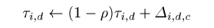
where ρ is the pheromone persistence and Δ_{i,d,c} is the relative solution quality of given candidate conformations.
- Result
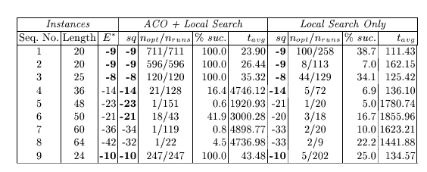
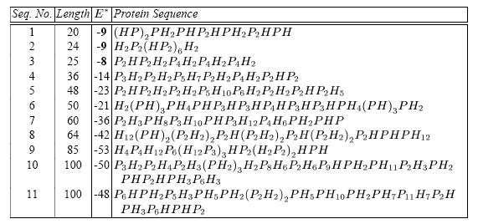
Created by : Chia-Chang Wang
Date : Mar. 29, 2005

